1. **Install Power BI Desktop and share the final screenshot of the report view page which appears when power desktop starts.**

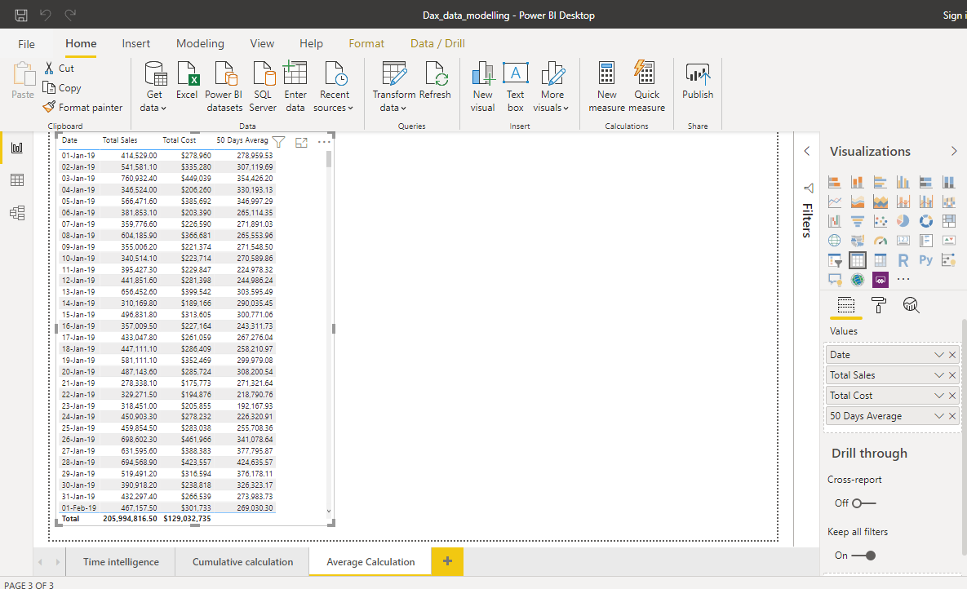

**2. Prepare a document and with the following screenshot**

Report View



Data View:

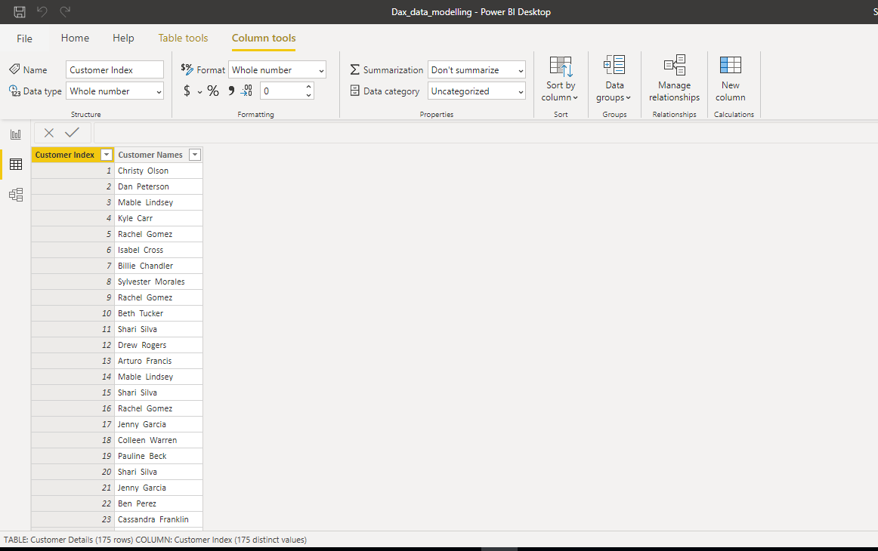

Advanced Editor:

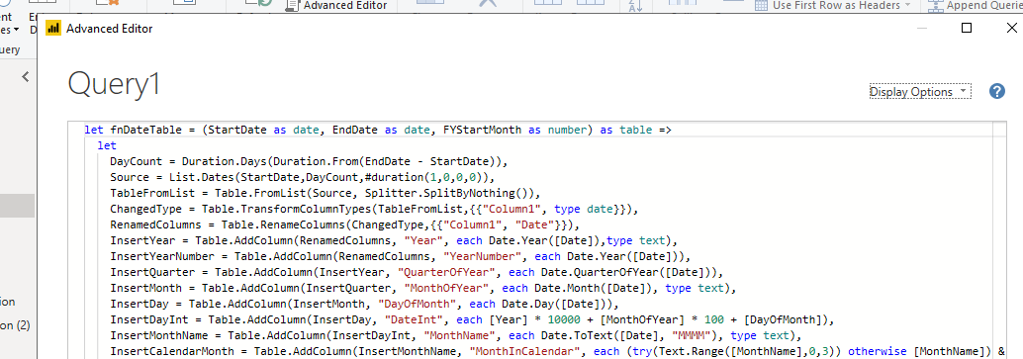

Model View:

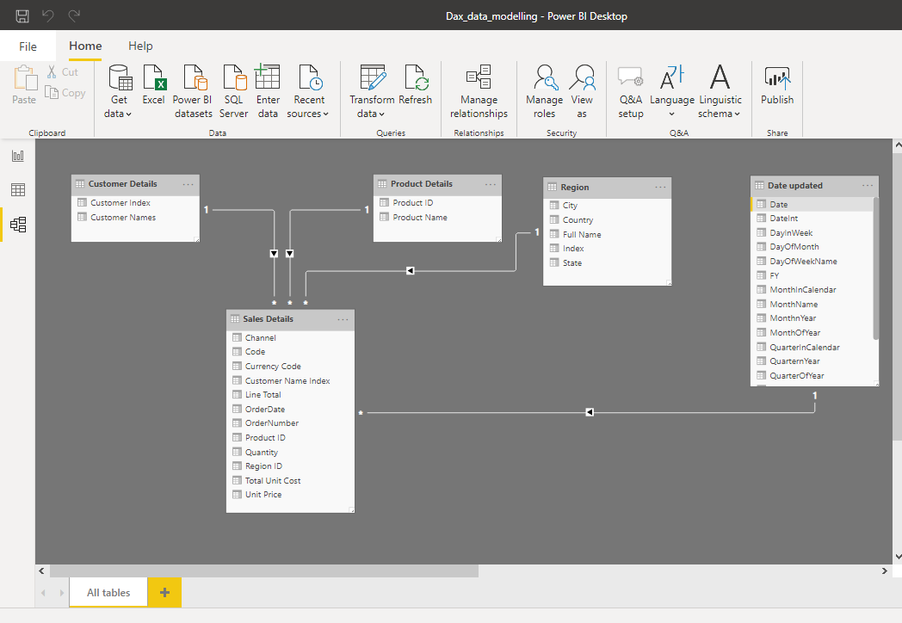

Power Query Editor

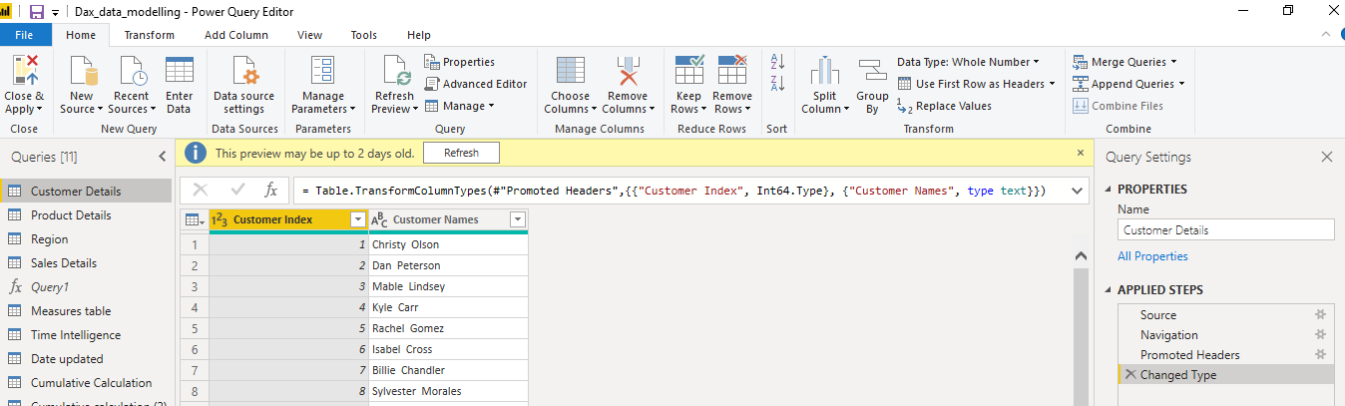

**3. Prepare a document with details of the following along with their price –**

Power BI Desktop – Power BI Desktop is a free application you install on your local computer that lets you connect to, transform, and visualize your data. With Power BI Desktop, you can connect to multiple different sources of data, and combine them (often called modeling) into a data model.

Power BI Pro – Power BI Pro is an individual user license that lets users read and interact with reports and dashboards that others have published to the Power BI service. Users with this license type can share content and collaborate with other Power BI Pro users. Costs at $9.99 user/month.

Power BI Premium - With Premium, anyone, whether they're inside or outside your organization can view your Power BI content including paginated and interactive reports without purchasing individual licenses. Premium enables widespread distribution of content by Pro users without requiring Pro licenses for recipients. Pricing as below.

